**VPM's K.G. Joshi College of Arts and N.G. Bedekar College of Commerce (Autonomous), Thane**

**Activity Report**

**1. Name of the Activity: Institutional Social Responsibility (ISR)**

**2. Name of the Department: Sanskrit**

**3 Day & Date: 22nd  February 2025**

**4.Venue:  Shirol, Umbarmali**

**5. Resource Person:  -**

**6. Number of  Participants :   Female- o2**

**7. Purpose of the Activity: The purpose of Institutional Social Responsibility (ISR) in Shirol, Umbarmali is to bridge the gap between educational institutions and rural communities by actively contributing to the social, educational, economic, and environmental development of the village. Through ISR, the institution aims to apply its knowledge, resources, and student involvement to bring about meaningful, sustainable change at the grassroots level.**

1. **Empowering the Local Community  
    To support the villagers through awareness programs, health camps, skill development, and literacy initiatives, helping them become more self-reliant and informed.**
2. **Enhancing Education and Digital Literacy  
    To improve the quality of education and digital awareness among children and youth by organizing teaching sessions, workshops, and access to learning resources.**
3. **Promoting Health and Hygiene  
    To create awareness about hygiene, sanitation, nutrition, and general health through health check-ups, clean-up drives, and informative sessions.**
4. **Supporting Sustainable Development  
    To encourage eco-friendly practices like tree plantation, waste management, water conservation, and energy awareness, helping build a greener village.**
5. **Building Student Social Responsibility  
    To instill values of empathy, civic responsibility, and community service in students by involving them in real-life social work and problem-solving.**
6. **Preserving Local Culture and Traditions  
    To engage with the community in celebrating and preserving local customs, traditions, and crafts, promoting cultural respect and pride.**
7. **Encouraging Participation and Collaboration  
    To work hand-in-hand with villagers, local leaders, schools, and organizations, ensuring that development efforts are inclusive, respectful, and need-based.**
8. **Gist of the Activity: Institutional Social Responsibility (ISR) in Shirol, Umbarmali The ISR activity in Shirol, Umbarmali village aims to connect the institution with the rural community by contributing to their educational, health, environmental, and social development. Through student participation and outreach programs, the initiative promotes community empowerment, awareness, and sustainable practices, while also instilling a sense of social responsibility and empathy among students. It serves as a collaborative effort to bring positive change at the grassroots level.**

**8. Teacher Incharge :-  Asst. Prof. Swati Bhalerao / Asst. Prof. Rohini Joshi**

**Thanks and Regards**

**Asst. Prof. Swati M. Bhalerao  Dr. Suchitra A. Naik**

**HoD Sanskrit Principal**

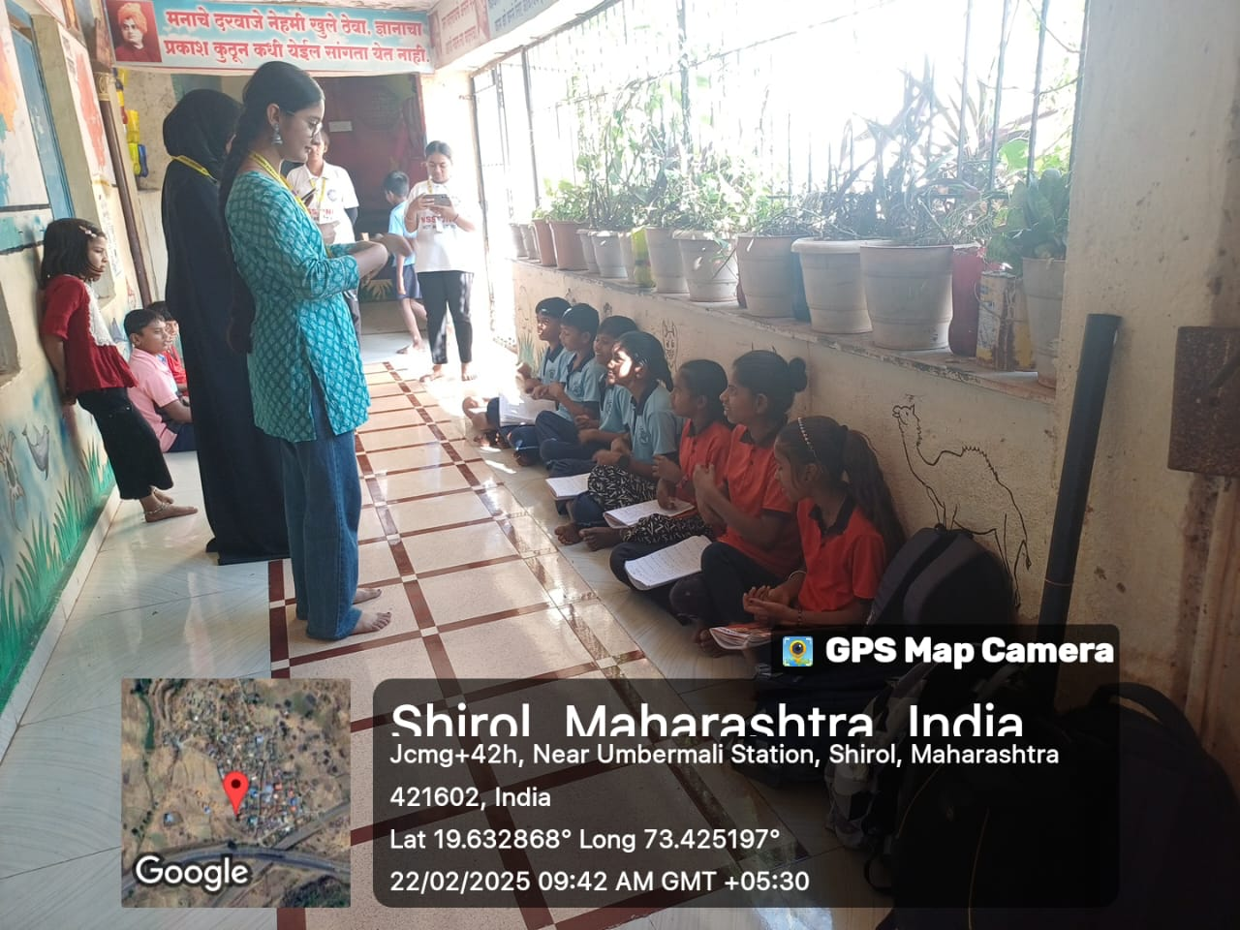

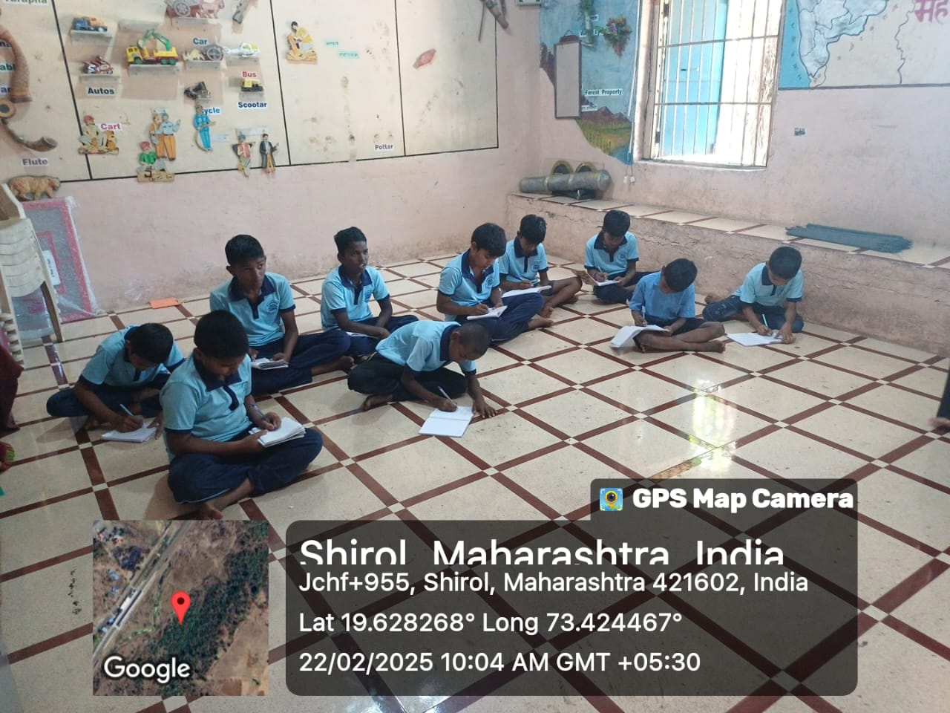

**Institutional Social Responsibility (ISR)22nd/2/2025 Venue:Shirol, Umbarmali**